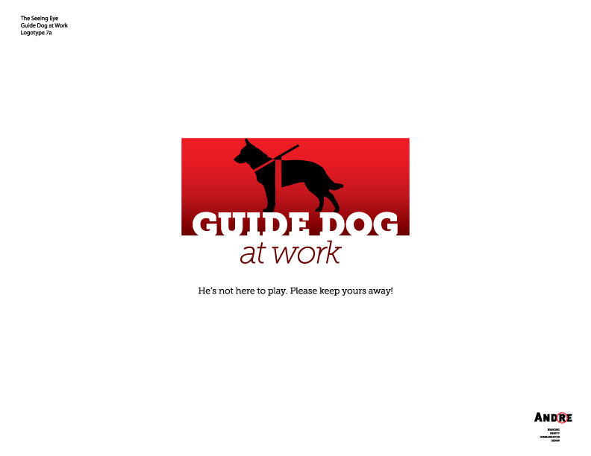

Guide Dog at Work. He’s not here to play. Please keep yours away!

LESSON PLAN

Suitable for grades Pre-K through 3
www.GuideDogAtWork.org

Overview
The Guide Dog at Work awareness campaign is intended to help everyone understand how guide dogs help blind and visually impaired people, and to stress why it’s so important to keep pet dogs a safe distance away from guide dogs at work. Students will learn that guide dogs are not like ordinary pets. Rather, they are responsible for leading someone who cannot see and they should never be distracted from their work. A lapse in the guide dog’s concentration or alertness could cause mistakes which might result in harm to the blind person or the guide dog. That’s why pet dogs should not be permitted to play, visit or otherwise distract a guide dog when it’s at work.

Objective
Students will learn:
- How guide dogs are different from ordinary pets
- How guide dogs help people who are blind or visually impaired
- Why it’s important for pet dogs to keep away from guide dogs at work
- How to help guide dog teams stay safe

Materials
- Guide Dog at Work video and projection equipment
View at http://www.guidedogatwork.org
Available in 60, 30, or 15 second clips upon request at advocacy@seeingeye.org
- Guide Dog at Work Campaign flyer
Download English and Spanish versions at www.GuideDogAtWork.org/tips

Guide Dog at Work Lesson Plan Discussion

Part I: Introduction and Video (four minutes)
- Raise your hand if you have a pet, or if you know someone who has a pet. Raise both of your hands if that pet is a dog.
- Do pet dogs have a job? Or do they just play ball, take naps, run around the yard, go for walks…
- Some dogs do have jobs - raise your hand if you can name a type of working dog.
Police dogs, therapy dogs, search & rescue dogs, service dogs like guide dogs…
- Today we are going to talk about guide dogs and how you can help them when they’re at work. Guide dogs help people who are blind (cannot see or cannot see very well) to safely and independently go to work, school, and anywhere they want to go.
- When a blind person and a guide dog work together, they are called a guide dog team. That makes them partners. Let's watch this video and see how a guide dog team works. Be sure to look for the special harness that the guide dog wears. It has a long handle that the blind person holds. That is the way you can tell that the dog is a guide dog and not just a pet. Also, watch and see how you can help guide dog teams do their work when pet dogs are nearby.

Part II: Questions to Ask after the Video (six minutes)
- What kinds of things did the guide dog in the video do to help her partner?
Safely cross streets; go around obstacles e.g. tables on the sidewalk, people, etc.; find doors inside and out, store counters, etc.
- What might happen if the guide dog in the video is not paying attention to her work?
The blind person or the guide dog could get hurt. The guide dog Might not notice an approaching car; she might bump her partner into someone or something; or she might step off a curb without remembering to warn her partner first.
- What does it mean when a guide dog has on its special harness?
The guide dog is working and should never be distracted from its work.
- Do guide dogs work all the time?
No. When the guide dog is not wearing its special harness, it’s not working so it can play, run and take naps just like any other dog.
- What did the guide dog in the video say that she needed to do in order to do her job well?
Stay focused on her work, and not stop to play or visit with other dogs because it could be really dangerous for her and her partner.
- What can you do to help a guide dog team stay safe?
Politely let everyone know why pet dogs should not be allowed to stop and play or visit with a guide dog when it’s trying to work.
- A good way to remember what to do when you see a guide dog is to say to yourself, "He's not here to play. Please keep yours away". Let's practice that...
- End the lesson by handing out the flyer and asking children to share them with their parents and to politely tell others what they have learned today.

