

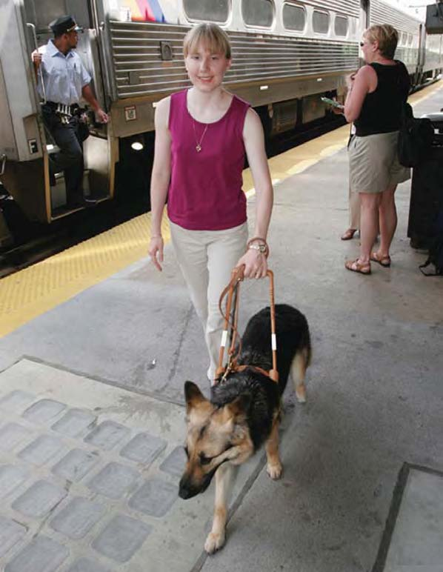

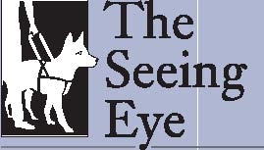
P.O. Box 375, Morristown, NJ, 07963
Gaining independence – and a faithful companion.

The freedom to set your own schedule and to move confidently anywhere you choose to travel can open the doors to a full and exciting life. Once you have achieved this high level of independence, you will be empowered to define success on your own terms.

Since 1929, The Seeing Eye has been matching visually impaired individuals with dog guides. These amazing animals become not only the eyes that give those they serve the freedom to navigate through life, but also become their devoted, loving companions.
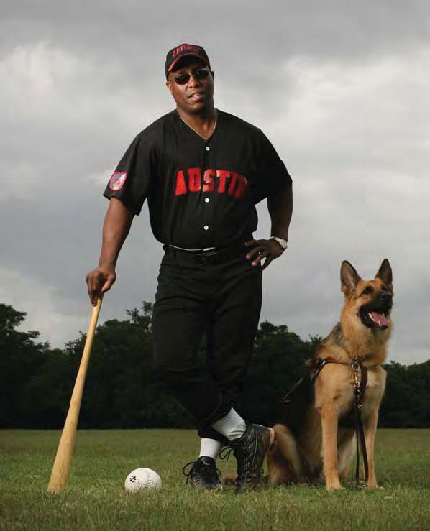

“I entrust my life to my Seeing Eye dog. He has never failed me. Neither has The Seeing Eye.”

Training with a Seeing Eye® dog.
Once you are accepted into the Seeing Eye program, you begin training at the school’s 60-acre campus, nestled in historic Washington Valley, New Jersey. Your “classroom” is also located on the streets of nearby Morristown, about 35 miles west of New York City. During your 19- to 26-day stay, you will live on campus in a spacious, comfortably furnished private room with a private bath.
Students are required to pay tuition costs themselves as their commitment to owning and caring for their Seeing Eye dogs. Once you leave the campus, you own your dog. For a first-time fee of $150, students receive their dog, its initial training and equipment, instruction with the dog, room and board, as well as round-trip transportation from anywhere in the United States or Canada. Payment may be made in interest-free increments over a period of years so there is never any financial hardship.
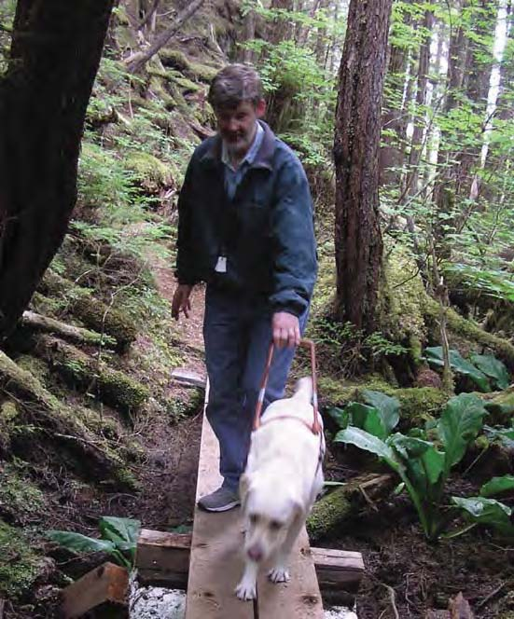

The Seeing Eye – more than a school… a philosophy of life.
The Seeing Eye offers a unique program, unlike that of any other dog guide school. Beyond a training program, The Seeing Eye represents a philosophy of life, one that embodies independence, respect and determination.
As a student, you receive much more than training and a dog guide that becomes your own. You also receive an unparalleled level of respect and support, not only when you are in training, but as a graduate living with a dog guide at your side.
“My Seeing Eye dog taught me to walk tall and raise my face, without fear, to the sun, wind and rain...she taught me to trust again.”
Once you enter the doors of The Seeing Eye, you are embraced as part of a family that will always be there for you, should your circumstances ever cause you to require additional training or assistance.

Apply to join the Seeing Eye family.
To apply for admission, contact The Seeing Eye Admissions Department at 1-800-539-4425 or at admissions@seeingeye.org to request an application packet. You can also fill out an application online by visiting www.SeeingEye.org. We look forward to hearing from you and having you join our Seeing Eye family.


Opening doors.
The opportunity to fulfill your dreams,achieve your goals and challenge yourselfto do more than you ever thought possiblemay be as close as the Seeing Eye dog atyour side. A Seeing Eye dog can be agood match for you if you have thefollowing qualifications:
- You are able to travel independently and demonstrate average balance, stamina and coordination.
- You are willing and able to give a dog enough work to maintain its training.
- You possess the mental and emotional stability to provide a dog with a loving, safe and stable home environment.
- You are in your late teens or older, and demonstrate the motivation, determination and desire to live the active lifestyle a Seeing Eye dog will provide.

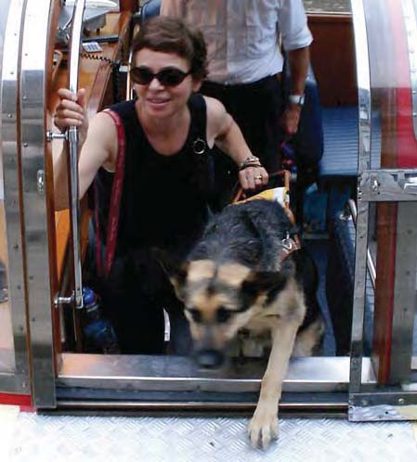

A tradition of innovation – and caring.
The pioneering spirit of The Seeing Eye’s founders helped to spread the dog guide movement throughout the world. That spirit lives on today at The Seeing Eye – in canine genetics and medical research and through innovations in individualized training techniques.
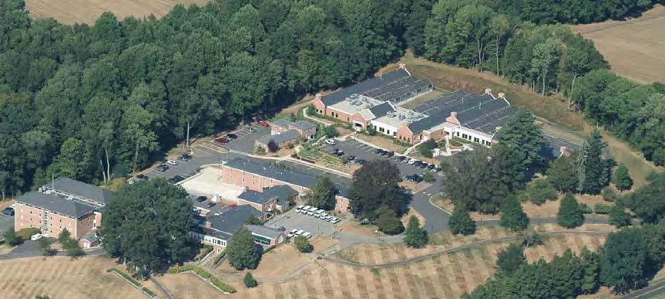
Beyond breakthroughs in science, The Seeing Eye is unparalleled in the level of follow-up support and services it provides to graduates and in the outstanding level of respect and personal attention the Seeing Eye “family” devotes to each student.
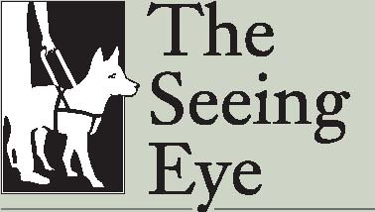
P.O. Box 375 • Morristown, NJ, 07963 www.SeeingEye.org • 1-800-539-4425
The Seeing Eye admits students of any race, color, national and ethnic origin to all the rights, privileges, programs, and activities generally accorded or made available to students at the school. It does not discriminate on the basis of race, color, national and ethnic origin in administration of its instructional policies, admissions policies, loan programs, and other school-administered programs.

